* Why will people come to your site?

The people who will come to my site are people interested in pottery: either in making it, or in purchasing work made by another. They should be people interested in making their world beautiful. The visitors could possibly be local, or not. There will be online education available for visitors from afar, and local classes available for people to take in person. The visitor should ideally be someone with disposable income, and extra time available for taking classes and learning something new.

* What questions will your visitors expect your site to answer for them?

The site should have easy access to a list of currently available and upcoming classes, as well as an easy way to view ceramics available for purchase. Also, the site will have access to useful beginner videos for those interested in making their own ceramic work. There will be beginner handbuilding classes, basic wheel throwing classes, as well as classes about glazing and decoration.

I will include a blurb about my background with ceramics:

I have been playing in the mud for 25 years. I have had the pleasure to take classes from some very creative individuals who were very generous with sharing information and skills. Making functional pottery that is useful and beautiful is my absolute favorite thing. Dotting your home with useful art brings a special energy into your home, and I love to be part of that relationship. Working with clay is incredibly satisfying and there is nothing more magical than a kiln opening. This wonderful sport/craft has brought me so much joy and meaning that I am excited to share that with you. You are welcome to learn how to make your own art or find something that I have made that speaks to you. You can choose to take an in person class, and I will fire your piece, or you can partake in the fun informational videos available on this site, and complete your own pieces in the comfort of your own home or studio.

An example of an upcoming class that will be available on the website:

Come Build a Cheese Board!

Saturday November 11th

2-4 pm

Join the fun!

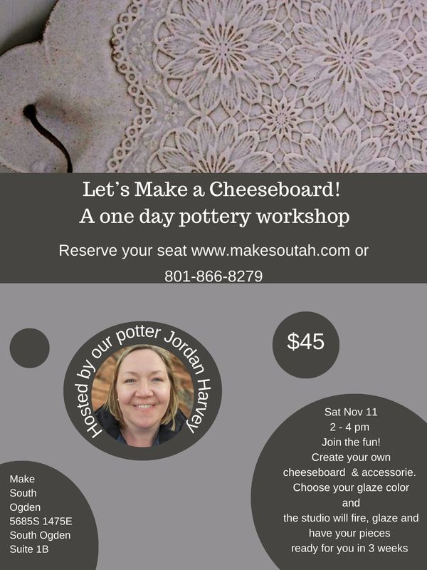

Create your own cheeseboard and accessories. The cheeseboard will be 7.5 inches wide and 9” long. You will make 3 small bowls for tasty tidbits, and 1 handbuilt ceramic spoon to match. Choose your glaze color and we will fire, glaze, and complete your piece in 3 weeks.

* What types of activities will visitors want to complete on your site?

Visitors to the site will have access to scheduling online classes, making purchases, and appeasing some of their curiosity about how handmade ceramic objects are made. They should be able to access a way to pay for and arrange shipment for ceramic pieces.

* What information is necessary to complete any actions your site offers?

I must gather photos of work being created, completed work, as well as populate a calendar, and make sure there is a way to reserve a spot in a class, and make payments.

* Why will your visitors come to your site instead of another to get this information or complete the actions?

Because my work is unique and appealing, and the site simple to navigate. The visitor will be able to find what they’re looking for and be happy with the scenery. I will link to this site from Instagram and Facebook. I am excited to be able to include information about my website on my business cards, as well as be able to send people interested in taking classes to a site, rather than trying to provide all the information through a text chain.